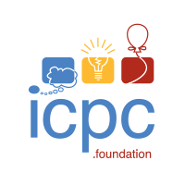
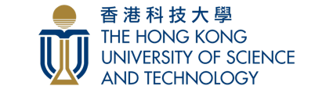

Invitation Letter

:

On behalf of the Local Organizing Committee, we would like to extend our most sincere invitation to you to participate in the

The 2025 ICPC Asia Hong Kong Regional Contest, 29-30 Nov, 2025

hosted by the Hong Kong University of Science and Technology. The International Collegiate Programming Contest (ICPC) is an algorithmic programming contest for college students. Teams of three, representing their university, work to solve the most real-world problems, fostering collaboration, creativity, innovation, and the ability to perform under pressure. Through training and competition, teams challenge each other to raise the bar on the possible. Quite simply, it is the oldest, largest, and most prestigious programming contest in the world.

We are looking forward to welcoming you to Hong Kong!

To apply for or register for the 2025 ICPC Asia Hong Kong Regional Contest, please send an email to Zhefan Rao at zhefan.rao@connect.ust.hk

Yours sincerely,


Qifeng Chen
Associate Professor
Department of Computer Science and Engineering
The Hong Kong University of Science and Technology
Clear Water Bay, Kowloon, Hong Kong, China
Email: cqf@ust.hk

